**Time Series Analysis**

Time Series: A collection of observations $X_{t}$, each one being recorded at time t. (Time could be discrete, t = 1,2,3,…, or continuous t > 0.)

Components of a time series

Classical decomposition

$$X_{t}=m_{t}+s_{t}+Y_{t}$$

$m_{t}$ = trend component (slowly changing in time)

$s_{t}$ = seasonal component (known period d=24(hourly), d=12(monthly))

$Y_{t}$ = random noise component (might contain irregular cyclical components of unknown frequency + other stuff).

Stationary Series:

1. The mean of the series should not be a function of time rather should be a constant.
2. The variance of the series should not be a function of time. This property is known as homoscedasticity.
3. The covariance of the ith term and the (i + m)th term should not be a function of time.

The random walk is not a stationary process as it has a time variant variance.

**A Time Series is (weakly) stationary:**

1. Mean $μ_{X}\left(t\right)$ is independent of $t;$
2. Covariance $γ_{X}\left(t+h, t\right)$ is independent of $t$ for each $h$.

Covariance: $γ_{X}\left(r,s\right)=Cov\left(X_{r}, X_{s}\right)=E[(X_{t}-μ_{X}(t))(X_{s}-μ_{X}(s))]$

**Dickey Fuller Test**

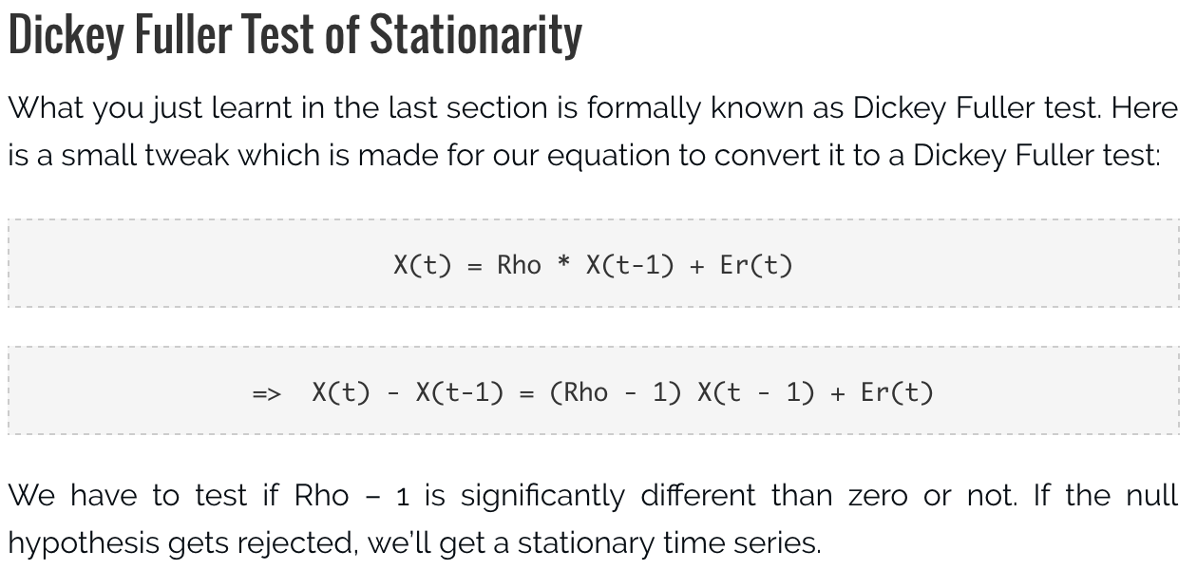

**AR or MA are not applicable on non-stationary series.** In case you get a non stationary series, you first need to stationarize the series (by taking difference / transformation) and then choose from the available time series models.

The primary difference between an AR and MA model is based on the correlation between time series objects at different time points. The correlation between x(t) and x(t-n) for n > order of MA is always zero. This directly flows from the fact that covariance between x(t) and x(t-n) is zero for MA models (something which we refer from the example taken in the previous section). However, the correlation of x(t) and x(t-n) gradually declines with n becoming larger in the AR model. This difference gets exploited irrespective of having the AR model or MA model. The correlation plot can give us the order of MA model.

